A picture containing clipart

Description generated with very high confidence

Azure 103 Module 2

Hands On - 14

Azure Certification Training

[**support@intellipaat.com**](mailto:support@intellipaat.com)

**+91-7022374614**

**US: 1-800-216-8930(Toll Free)**

**Azure 103 Module 2, Hands On – 14**

**Using BLOB Storage Archive.**

**Step 1:** Open Storage Account.

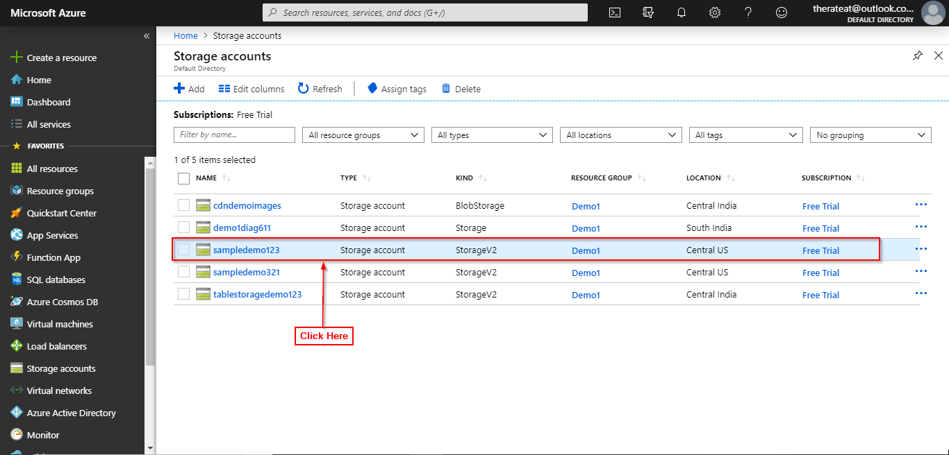

**Step 2:** Open BLOB Storage.

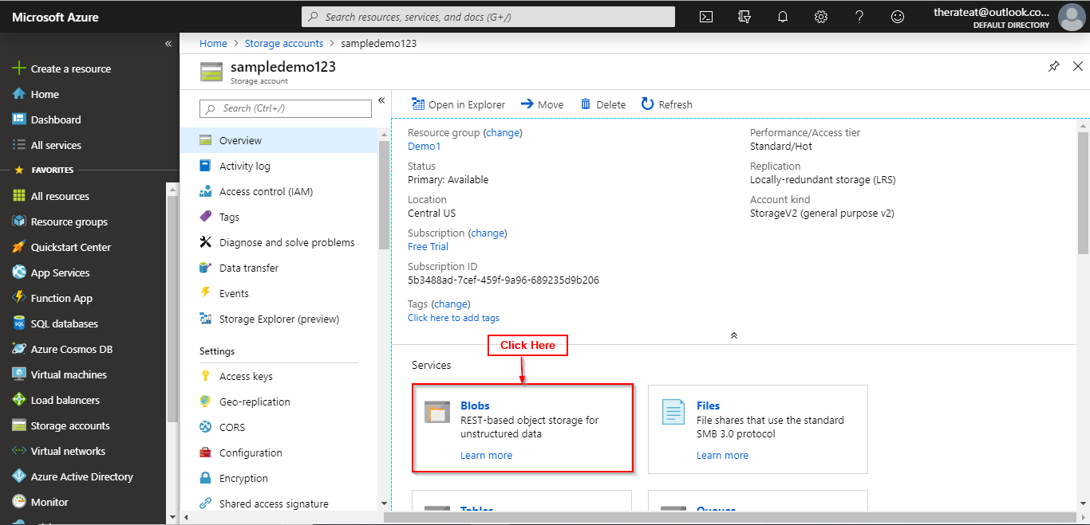

**Step 3:** Click on a container.

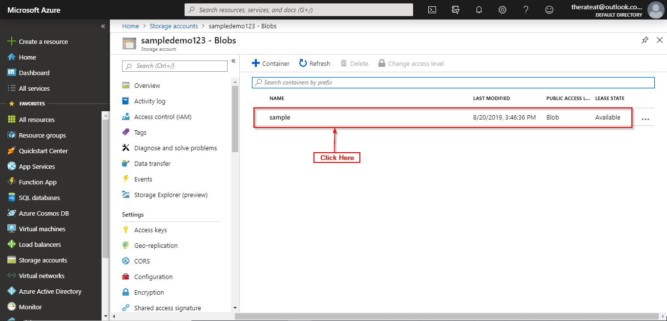

**Step 4:** Click on the blob item you wish to archive.

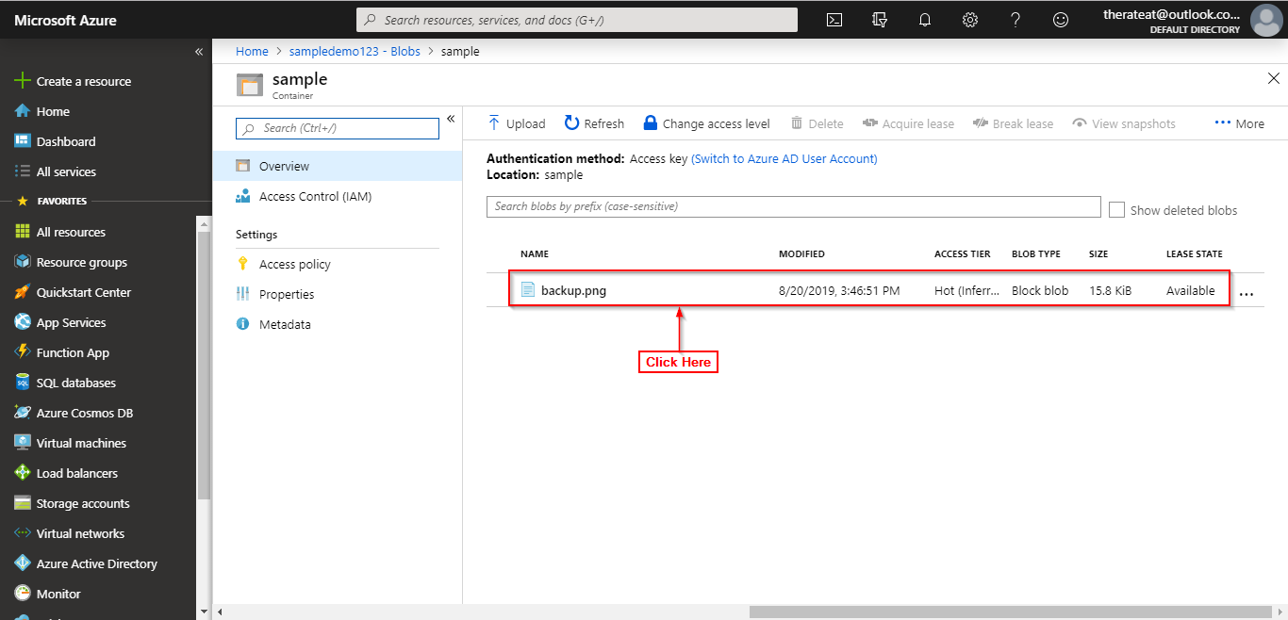

**Step 5:** Click on change tier.

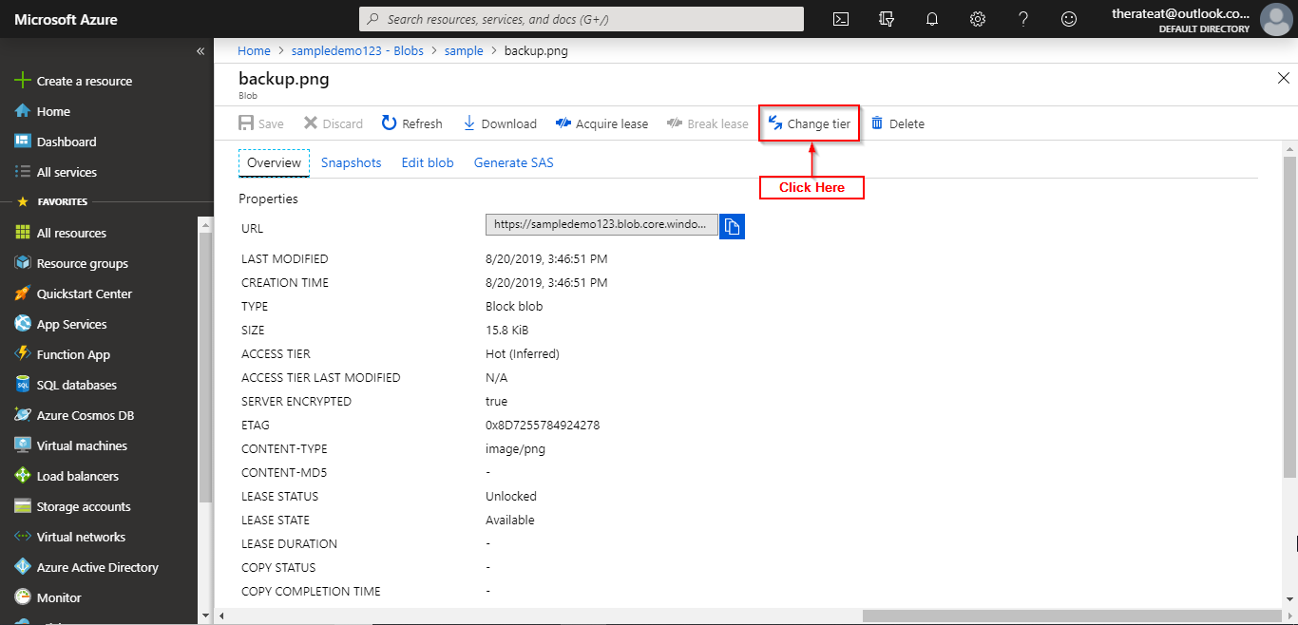

**Step 6:** Select Archive from the dropdown list.

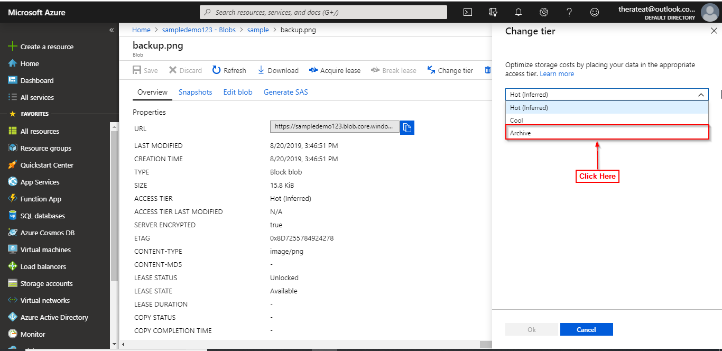

**Step 7:** Click on Ok.

